**Title** :- Case study on Microsoft azure to learn about Microsoft Azure is a cloud computing

platform and infrastructure, created by Microsoft, for building, deploying and

managing applications and services through a global network of Microsoft-managed

datacenters. How it work, different services provided by it.

**Objective** :- From this experiment, the students will be able to,

* Understand the concepts of building, deploying and managing applications on Microsft Azure.
* Understand Azure services and its configuration via its data centers.

**Problem Statement** :- To understand basically all the services, its platform how its works,

configuration of its infrastructure by creating interacting applications

through the global network of Azure.

**Outcomes** :-

* + Student can study archiecture of azure and get benefit from various services.
  + By using services, skills, and tools necessary for creating applications, one will be able to understand the application work and data flow.
  + One will get to know the stages of developing app through Azure.

**Software and Hardware Requirements** :- (**MICROSOFT AZURE**)

* Software:- Windows/Linux Operating System, Azure Account
* Hardware:- Nil

**Theory**:-

Microsoft has leveraged its constantly-expanding worldwide network of data centers to create Azure, a cloud platform for building, deploying, and managing services and applications, anywhere. Azure lets you add cloud capabilities to your existing network through its platform as a service (PaaS) model, or entrust Microsoft with all of your computing and network needs with Infrastructure as a Service (IaaS). Either option provides secure, reliable access to your cloud hosted data—one built on Microsoft’s proven architecture. Azure provides an ever expanding array of products and services designed to meet all your needs through one convenient, easy to manage platform. Below are just some of the capabilities Microsoft offers through Azure and tips for determining if the Microsoft cloud is the right choice for your organization.

Microsoft maintains a growing directory of Azure services, with more being added all the time. All the elements necessary to build a virtual network and deliver services or applications to a global audience are available, including:-

### **Virtual machines**

Create Microsoft or Linux virtual machines (VMs) in just minutes from a wide selection of marketplace templates or from your own custom machine images. These cloud-based VMs will host your apps and services as if they resided in your own data center.

### **SQL databases**

Azure offers managed SQL relational databases, from one to an unlimited number, as a service.This saves you overhead and expenses on hardware, software, and the need for in-house expertise.

### **Azure Active Directory Domain services**

Built on the same proven technology as Windows Active Directory, this service for Azure lets you remotely manage group policy, authentication, and everything else. This makes moving and existing security structure partially or totally to the cloud as easy as a few clicks.

### **Application services**

With Azure it’s easier than ever to create and globally deploy applications that are compatible on all popular web and portable platforms. Reliable, scalable cloud access lets you respond quickly to your business’s ebb and flow, saving time and money. With the introduction of Azure WebApps to the Azure Marketplace, it’s easier than ever to manage production, testing and deployment of web applications that scale as quickly as your business. Prebuilt APIs for popular cloud services like Office 365, Salesforce and more greatly accelerate development.

### **Visual Studio team services**

An add-on service available under Azure, Visual Studio team services offer a complete application lifecycle management (ALM) solution in the Microsoft cloud. Developers can share and track code changes, perform load testing, and deliver applications to production while collaborating in Azure from all over the world. Visual Studio team services simplify development and delivery for large companies or new ones building a service portfolio.

### **Storage**

Count on Microsoft’s global infrastructure to provide safe, highly accessible data storage. With massive scalability and an intelligent pricing structure that lets you store infrequently accessed data at a huge savings, building a safe and cost-effective storage plan is simple in Microsoft Azure.

**Program Codes with Output Screenshots**:- **AZURE ACCOUNT CREATION**

Step 1)Go to [https://www.azure.com](https://www.azure.com/)and click the green “Start free” button.

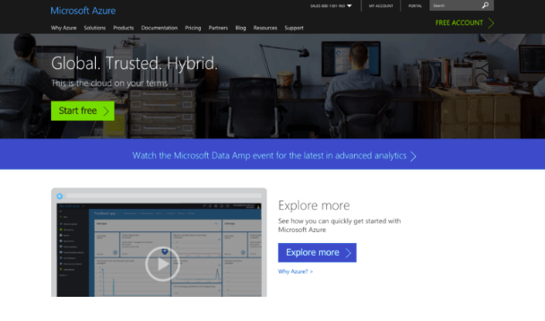

Step 2) Next, click another “Start free” button.

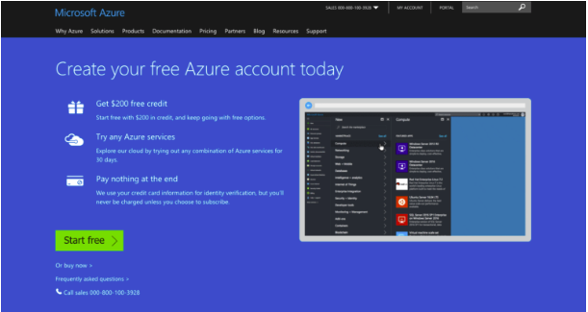

Step 3) If you already have an account with Microsoft, for example, Office 365, you’ll be prompted to log in.



Step 4) When you log in, some of your details may already be there.

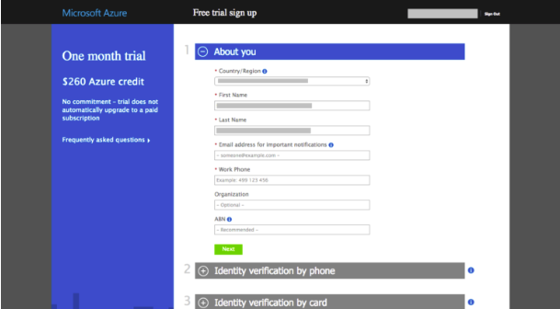

Step 5) Follow the prompts to verify your account by phone (I used SMS).

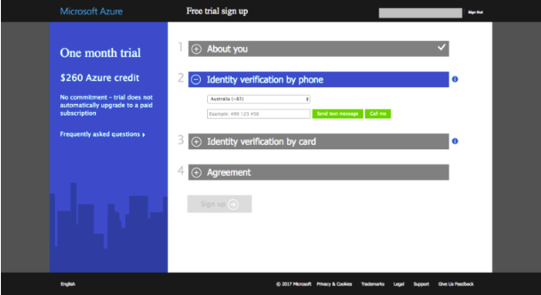

Step 6) You’ll also need to supply a valid credit card. Prepaid credit cards won’t work — you’ll need a “normal” credit or debit card. There is no charge involved with the setting up of a trial account. Microsoft just wants to see your card to verify your identity. There will be, however, a record for a $0 transaction on your bank statement. In my bank it looks like this:



Step 7) Next – tick “I agree” and click “Sign Up.”

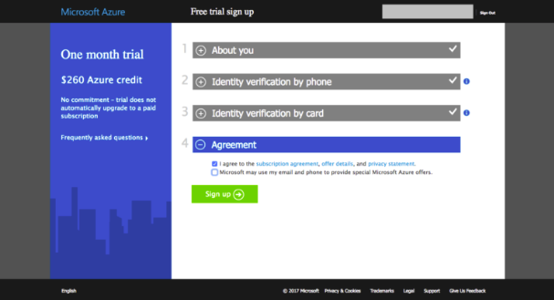

Step 8) Within a few seconds, your account will be ready.

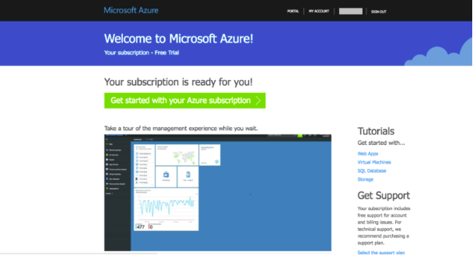

Step 9) That’s it! Your Microsoft Azure account has been created. To continue, click the “My Account” link at the top right corner or go straight to the Microsoft Azure Portal: <https://portal.azure.com/>

**Conclusion**:- Students were able to get themselves hands-on experience on azure interface and

also gained knowledge about implentation of a cloud application.